# ABSTRACT

Disease Based Diet Plan in Android Based Application. This App is designed for Diet facilitation according to their disease because Healthy diet provides the body with fundamental nutrition. A healthy diet supports energy desires. A healthy diet plan Emphasizes vegetables, fruits, whole grains, and fat-free or low-fat dairy products Includes lean meats, poultry, fish, beans, eggs, and nuts Limits saturated and transfats, sodium, and added sugars. The goals of Disease Based Diet Plan are to give user the feature of making diet plans according to their disease to main their health accordingly. This app has feature of adding Food and Disease if not available. User can activate and Deactivate plan and also if they want to delete it they can also delete it. One major feature of this application is that we have some suggested plan which are given by dietitian so user can also activate those plan if they want to. So basically this app will help user to maintain their diet plan according to their disease.

**TABLE OF FIGURES**

Figure 1: Conceptual Diagram 5

Figure 2: Data Flow Diagram 5

Figure 3: Entity Relation Ship Diagram 6

Figure 4: Splash Screen 7

Figure 5: Menu 8

Figure 6: Disease Selection 9

Figure 7: Create Plan 10

Figure 8: Food Selection for Plan 11

Figure 9: User Created Plans 12

Figure 11: Plan Details 13

Figure 12: Add Food 14

Figure 13 Add Disease 15

Table of Contents

CERTIFICATE i

DEDICATION ii

ACKNOWLEDGEMENT iii

ABSTRACT iv

CHAPTER 1 DISEASE BASED DIET PLAN 1

1.1. Introduction 1

1.2. Problem Statement 1

1.3. Proposed Solution 1

1.4. Related Work 1

1.5. Objective and Scope 2

1.6. Features 2

CHAPTER 2 TOOLS AND TECHNOLOGY 3

2.1 Android 3

2.2 SqliteBrowser 3

2.3 Related Project 4

2.4 Drawbacks 4

CHAPTER 3 CONCEPTUAL MODELING 5

3.1 Conceptual Diagram 5

3.2 Data Flow Diagram 5

3.3 Entity Relation Diagram 6

CHAPTER 4 Design And Implementation 7

4.1 User Guide 7

CONCLUSION 16

REFERENCES 17

# CHAPTER 1

# DISEASE BASED DIET PLAN

### Introduction

A healthy diet is one that helps to maintain or improve overall health. A healthy diet provides the body with essential nutrition: fluid, adequate essential amino acids from protein, essential fatty acids, vitamins, minerals, and adequate calories. The requirements for a healthy diet can be met from a variety of plant-based and animal-based foods. A healthy diet supports energy needs and provides for human nutrition without exposure to toxicity or excessive weight gain from consuming excessive amounts. Where lack of calories is not an issue, a properly balanced diet (in addition to exercise) is also thought to be important for lowering health risks, such as obesity, heart disease, type 2 diabetes, hypertension, and cancer. Various nutrition guides are published by medical and governmental institutions to educate the public on what they should be eating to promote health. Nutrition facts labels are also mandatory in some countries to allow consumers to choose foods based on the components relevant to health.



### Problem Statement

People cannot find Diet plan according to their Disease. People don't know which food item is good for them. Essential micronutrients such as vitamins and certain minerals. Avoiding directly poisonous (e.g. heavy metals) and carcinogenic (e.g. benzene) substances. Avoiding foods contaminated by human pathogens (e.g. E. coli, tapeworm eggs).



### Proposed Solution

Making Diet Plan according to disease is much easier. User can add Food and Disease if not available. User has to set his disease only one time. We are providing Some Suggested Plans to help users. Diet facilitation according to their disease. The user can create Diet plan according to their disease. A system In which a complete diet plan is suggested for well-known diseases Like diabetes, Hepatitis-C, Hepatitis-B, Asthma... Etc.



### Related Work

1. **Medscape:**

Medscape has Following features

1. Medscape gives you medical news from Medscape News.
2. Get daily news from any of the 34 specialties.
3. Just select the specialties that you like to follow.
4. Devices that are supported by Medscape are the Motorola Droid, the Motorola Droid X, Motorola Droid 2, HTC Incredible, Samsung Galaxy S, and the Samsung Galaxy Tab.

### Objective and Scope

1. The System is designed for the enhancement or development of Computerized Diet plan.
2. It includes the features that can Add Disease and Food record, Edit Disease.
3. Save the Plan for Future use.
4. Create different types of plans.
5. To list down all food items according to all diseases

### Features

1. User friendly
2. Reliable and easy to use
3. Get recommendations for healthy foods based on what you currently eat
4. Get Plan from the community
5. Track your food Quantity
6. Track the quality of calories, not just quantity

# CHAPTER 2

# TOOLS AND TECHNOLOGY

Tools and Technology that are Used for the development of Disease Based Diet Plan Project are discussed as follow.

### 2.1 Android

Android is a mobile operating system(OS) based on the Linux Kernel and currently developed by Google. With a user interface based on direct manipulation, Android is designed primarily for touch screens mobile devices such as smartphones and tablet computers, with specialized user interfaces for televisions(Android TV), cars(Android Auto), and wristwatches (Android Wear).The OS uses touch inputs that loosely correspond to real-world actions, like swiping, tapping, pinching, and reverse pinching to manipulate-screen objects and virtual keyboard.Despite being primarily designed for touch screen input, it has also been used in game consoles, digital cameras, regular PC, and other electronics.Asof2015, Android has the largest installed base of all general-purpose operating systems.

### 2.2 SqliteBrowser

DB Browser for SQLite is high quality, visual, open source-tool create, design, and edit database files compatible with SQLite.

It is for users and developers wanting to create databases, search, and edit data.It uses a familiar spreadsheet-like interface, and you don't need to learn complicated SQL commands.

1. Controls and wizards are available for users to:
2. Create and compact database files
3. Create, define, modify and delete tables
4. Create, define and delete indexes
5. Browse, edit, add and delete records
6. Search records
7. Import and export records as text
8. Import and export tables from/to CSV files
9. Import and export databases from/to SQL dump files
10. Issue SQL queries and inspect the results
11. Examine a log all SQL commands issued by the application

### 2.3 Related Project

There are many applications on google play related to Diet Plan.

#### Fooducate

Fooducate have some personalization features require upgrade to a premium account

1. Age, gender, weight, height, activity level
2. Desired weight loss rate
3. Crab control
4. Health conditions
5. Dietary goals (vegetarian, vegan, paleo)
6. Gluten free and other allergens - lactose, shellfish, eggs, etc.

#### Women Health Tracker

Woman Health Tracker features.

* + 1. Improve women’s health
    2. Innovative ovulation tracker and fertility charts, powered by sophisticated data analysis.
    3. Predict your peak fertility days and upcoming period with a period tracker that gets smarter over time.
    4. Community and partner support, not found in any other ovulation or period tracker.
    5. Personalized reproductive health and fertility insights based on your ovulation, period timing, and other health data.
    6. Reminders for your medications, birth control and/or other contraception.

### 2.4 Drawbacks

Current Applications in the market does not facilitate user with a single application that contains following features:

1. Reliable and easy to installed
2. User friendly
3. Share features
4. Disease Based diet Plan
5. Most needed Features are not available in free apps.

# CHAPTER 3

# CONCEPTUAL MODELING

Disease Based Diet Plan app started by creating Entity Relationship Diagram, Data Flow Diagram, Conceptual Diagram.

### 3.1 Conceptual Diagram

User interact with Android app and Send Request for App data through Web service. Then data is send back to android Database and Directory. Then user use app using Android App without getting connected with Web service.

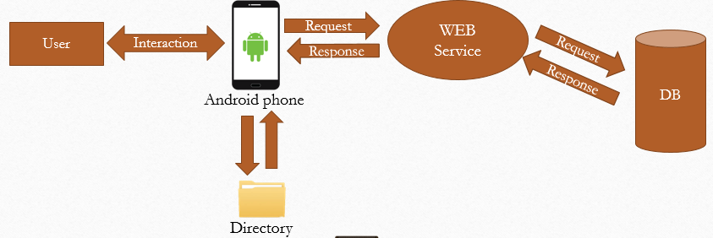

Figure 1: Conceptual Diagram

### 3.2 Data Flow Diagram

User Request for Create Plan, Saved Plans, View Plan, Suggested Plans, Add Food, Add Disease. Then Request is send to Internal Database and user get responce back in from of words and pic.

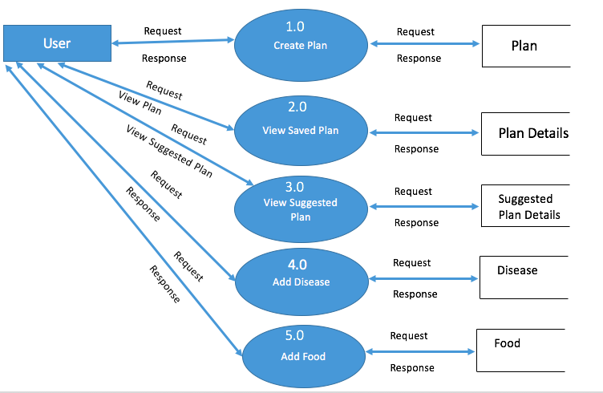

Figure 2: Data Flow Diagram

### 3.3 Entity Relation Diagram

In this Figure, Database connection are discussed. Where connection is defined between Food, Disease, Plans, Plan Details, Category, Food and Disease Tables.

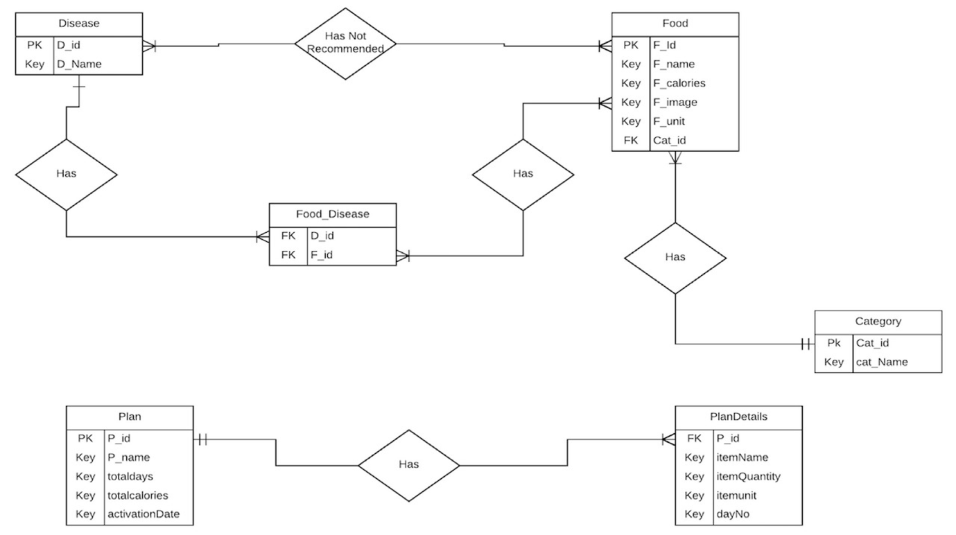

Figure 3: Entity Relation Ship Diagram

# CHAPTER 4

# Design And Implementation

### 4.1 User Guide

Loading Screen Appears at the Start of App. On this Screen App is connected to Web Service and Get application data. This Screen is created by using Image View and Progress Bar.

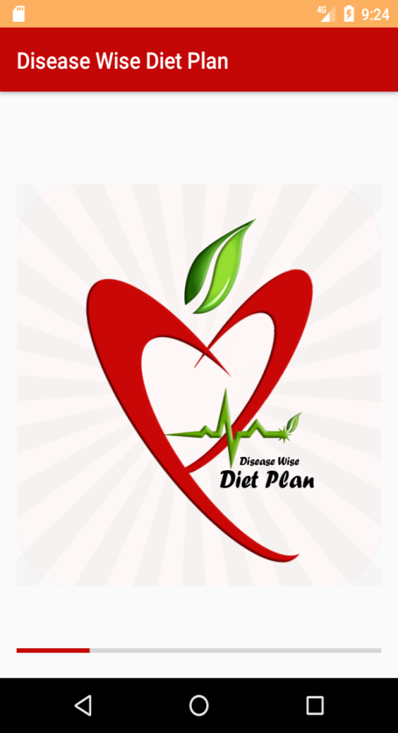

Figure 4: Splash Screen

This is the Picture of Toggle Menu Of App. From which you can switch screens. When User Click on Create Plan then Figure 8: Create Plan appears. When User click on Add Disease Figure 14 Add Disease appears, Add Food Figure 13: Add Food appears , Show My Plan Figure 12: Plan Details Appears , Set Disease Figure 6: Disease Selection appears.

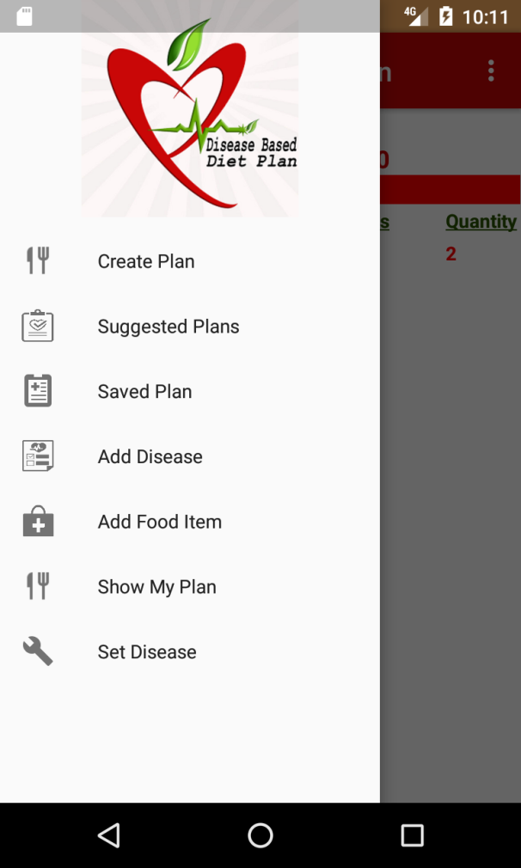

Figure 5: Menu

These are pictures of Disease selection Activity. when user clicks on dropdown item the Multi item selector Pop ups. Then user select his Disease he suffer from and click Accept. then Click on Set Disease button to set his diseases.

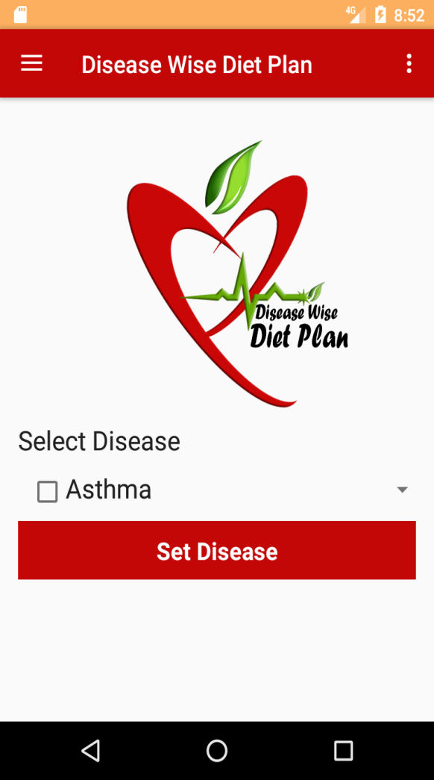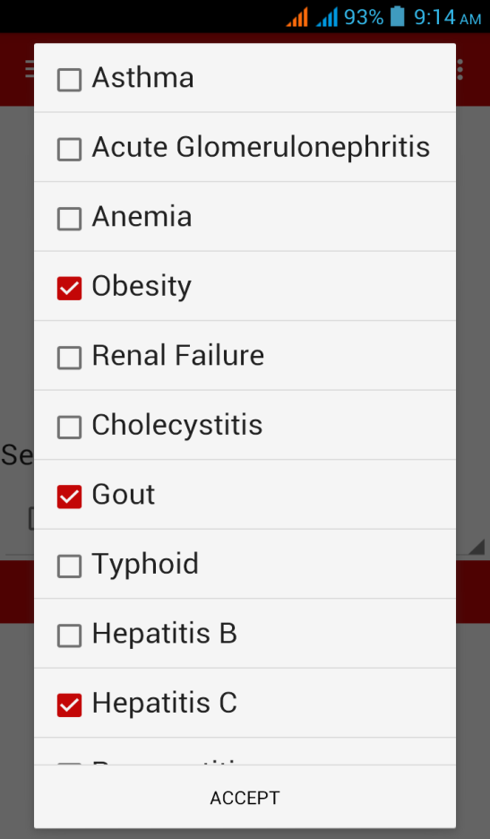

Figure 6: Disease Selection

When User Clicks on Create Plan From Menu. When this screen will appear. Where User can Enter his Plan names in strings , Desires Calories a Day in number and Days in number. Then click Next. This Screen is created with Text View, Edit Text, Button.

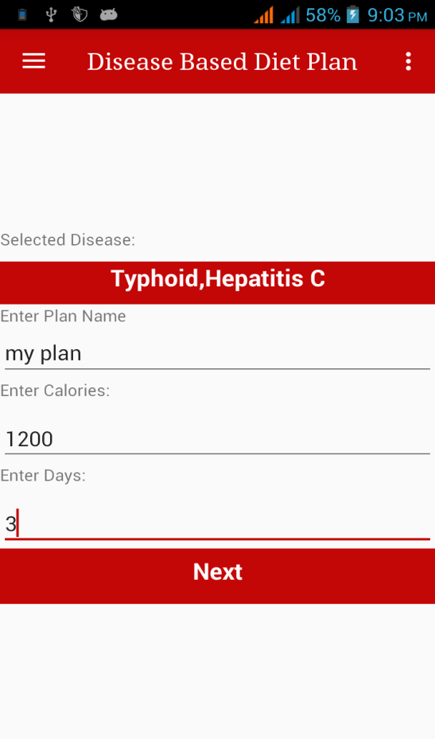

Figure 7: Create Plan

After Clicking Next 1st screen will appear. User can change Days from Day1-Day7(User Entered Days). If User want to make Same Plan for each day Use toggle button 'Same for all Days'. User can change meal time and Food type. If user click on gray item which is Disabled for him, he get Popup message. on other item he have to enter quantity for desired item.

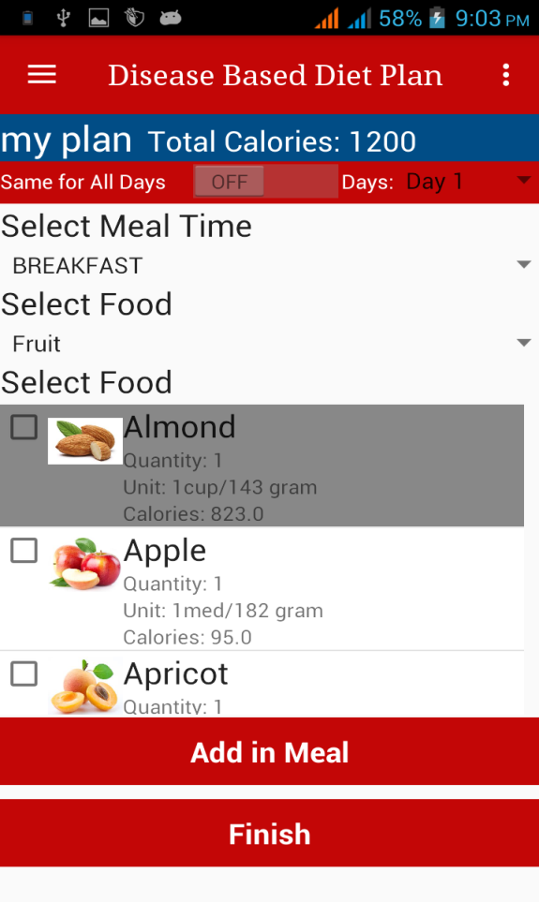 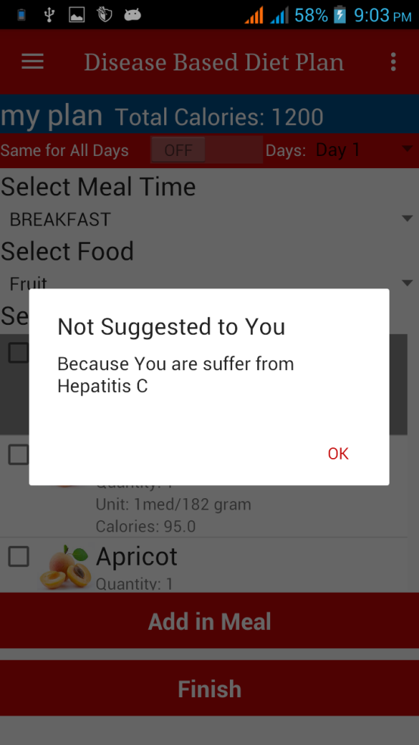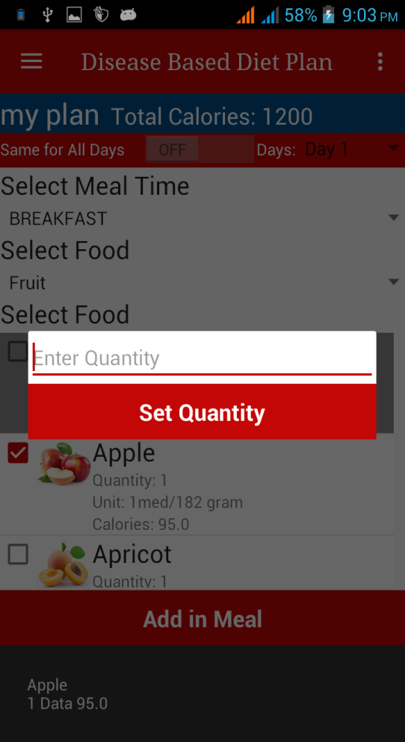

Figure 8: Food Selection for Plan

When user click on Saved Plan from menu. then Figure 11 will appear he can select any plan he want. When he click popup option will appear. where he can view plan, Activate it and Delete it.

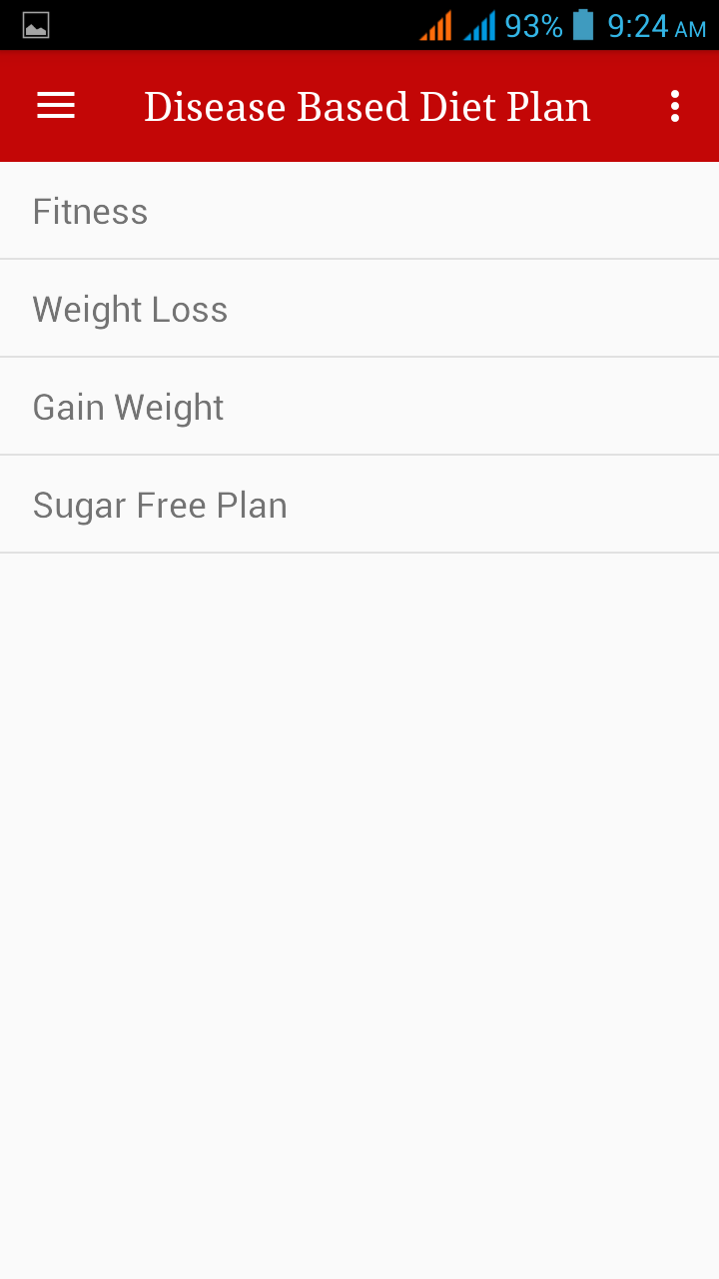 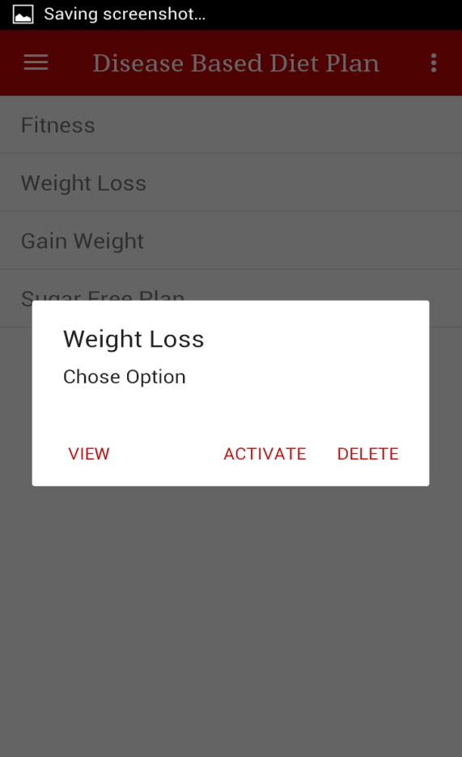

Figure 9: User Created Plans

When he Click on View Figure 13 will appear and he can see Plan details. This screen is created with Text View, List View.

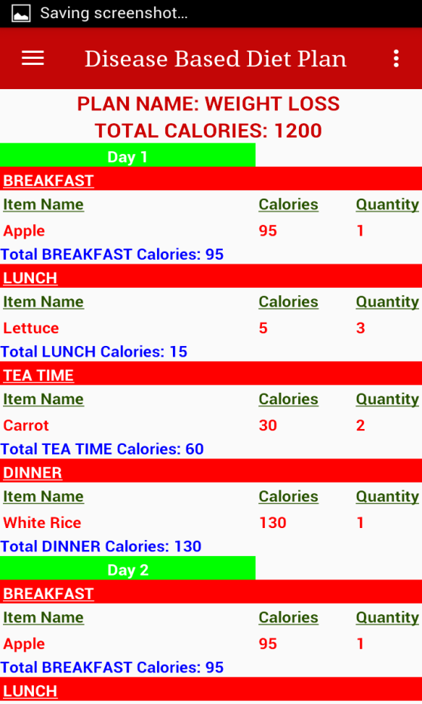

Figure 11: Plan Details

When User click on Add Food Item then first screen will appear. User can enter Food name, Calories, Unit(e.g. Gram and dozens). He can select Food category from dropdown menu. and Add Picture of Food item from Gallery. This Page is created by using Edit Text, Spinner, Text View, Buttons, Gallery.

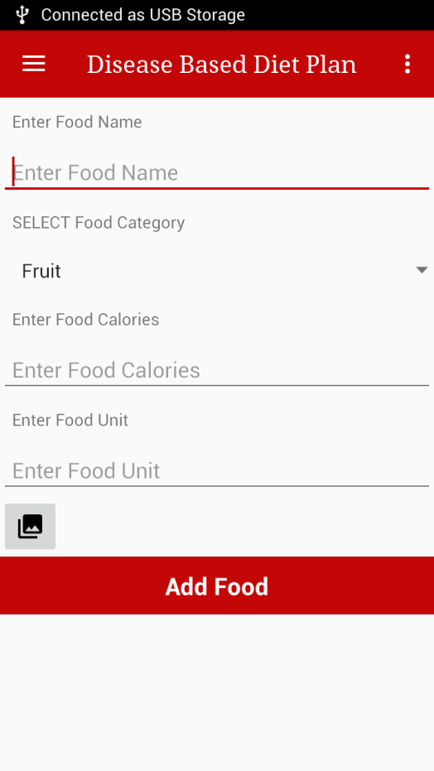 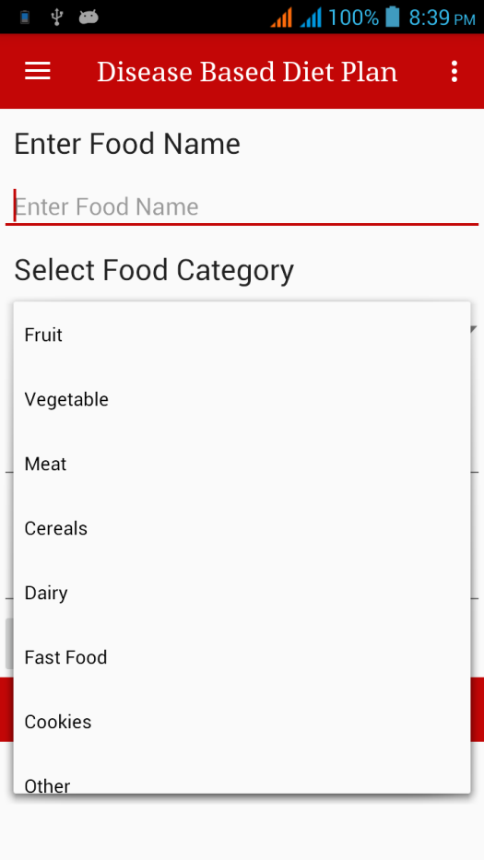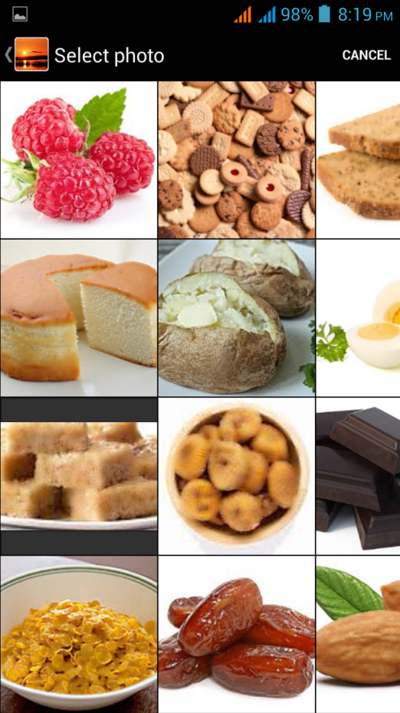

Figure 12: Add Food

When User click on Add Disease from Menu then this screen will appear. where he can enter disease name and select not suggested food item from list. This Screen is Created by using Text View, Edit Text, List View and Button.

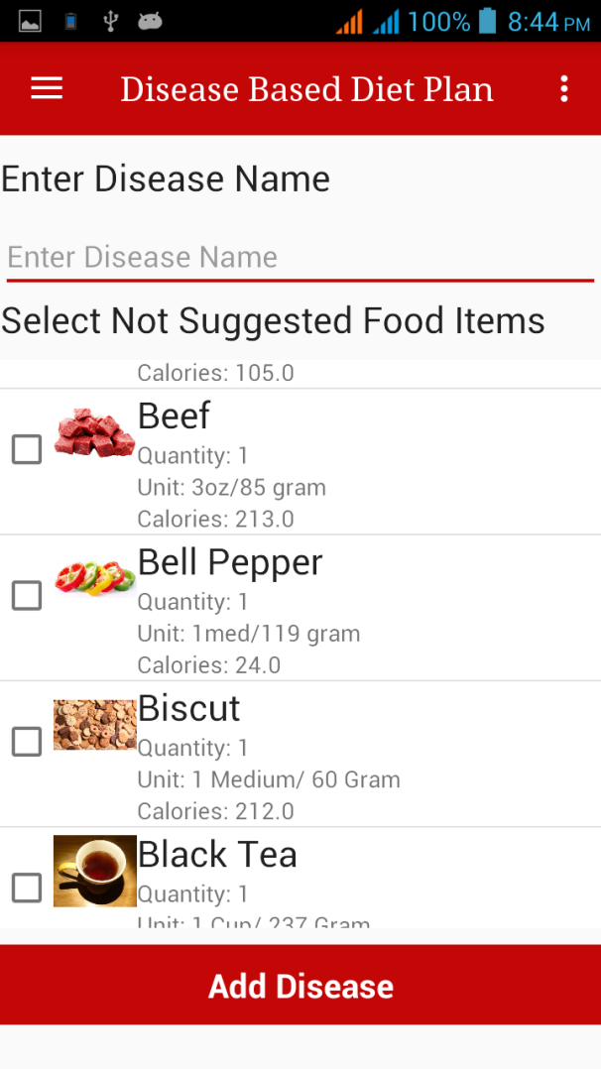

Figure 13 Add Disease

# CONCLUSION



The application is developed for Patients and Healthy Persons both. Every age person can use the app to create a diet plan and follow it daily.

### Future Direction

In future, application can be updated. We will add more authenticity suggested food for the disease. We will also add Doctor made diet Plans. We will add More foods and food Categories.

### Limitation

The application is dependent on Android Smartphone devices only. The current application only contains the Food item, fewer Diseases.

# REFERENCES

1. WCF Web-Service

<https://docs.microsoft.com/en-us/dotnet/framework/wcf/feature-details/how-to-create-a-basic-wcf-web-http-service>

1. SQLite Database

https://developer.android.com/training/basics/data-storage/databases.html

1. Photo Library Access

<http://stackoverflow.com/questions/20595227/how-do-i-get-an-image-from-the-ios-photo-library-and-display-it-in-in-uiwebview>

1. Stack Overflow

https://stackoverflow.com/documentation/android/topics

1. Android Developers Website

https://developer.android.com/training/index.html